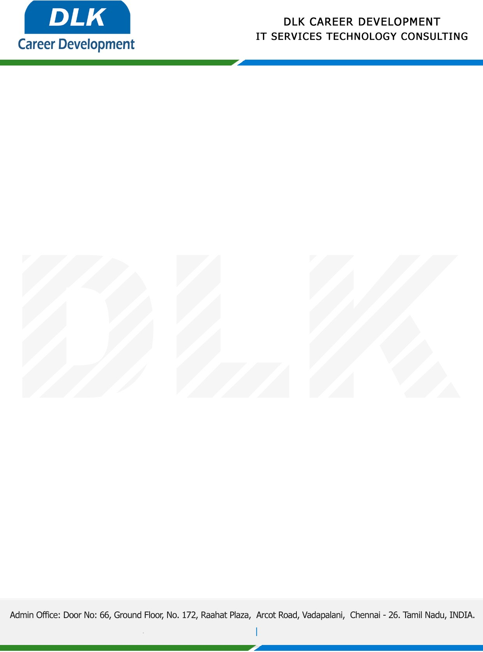

Date: 05/ January / 2023

**To**

Department of BCA ( [Computer Application),](https://www.cseindia.org/)

Head of Department,

Alpha arts and science college, Chennai - 600116.

**Sub: Letter of Project Acceptance**

This is to certify that final year students of has accepted the Project Work duration from **February 2023** to **April 2023** under the domain **“Java”.** During the Project, all information and data collected from you should be kept confidential.

**Team Members:**

1. MR LOKESHWARAN J (REG NO: 212002758)
2. MR PRATHICK POOSHAN G (REG NO: 212002767)
3. MR SARAVANAN M (REG NO: 212002782)

**Topic:** Smart City Information based on Location.

We appreciate your interest in **DLK CAREER DEVELOPMENT**

